Artistic musings of the Bishops of Winchester

(Tenure of Bishopric dates)
These heads are part of a collaborative project by the University of Creative Arts at Farnham which form a new exhibit at Farnham castle. They are made in crank and fired to 1300c, and not subjected to the Raku process.

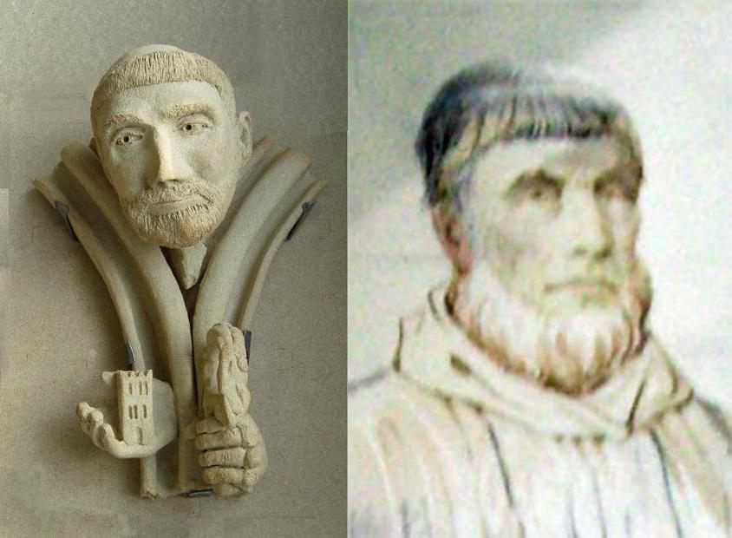
Henry the Blois (1129-1171) To some, Henry of Blois was a sort of monster: half monk, half knight. To others, he was “above gold and gems”. He was a great patron to the Arts and Architecture and was an art connoisseur. He built the original motte and Bailey in the castle. He was a flamboyant character, and loved jewellery, (particularly rings), and also exotic animals and reputedly kept a managerie. In his left hand he holds “The St Nicholas crosier” the original of which can now be seen in the Victoria and Albert museum.

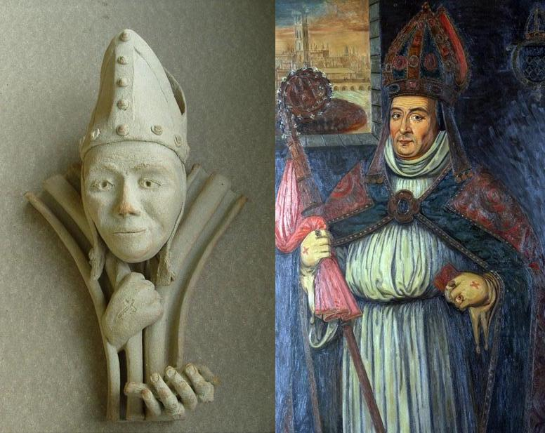
William Wayneflete (1447-1486). A chubby individual who liked his food. He was a schoolteacher with a tendency to pontificate. In the portrait, there are intriguing crosses on the outside of his hands. It is not clear if these were made in ink or if they were tattooed. They are however represented on the sculpture, and the right hand is held in a pontificatory gesture. He also appeared to enjoy rings.

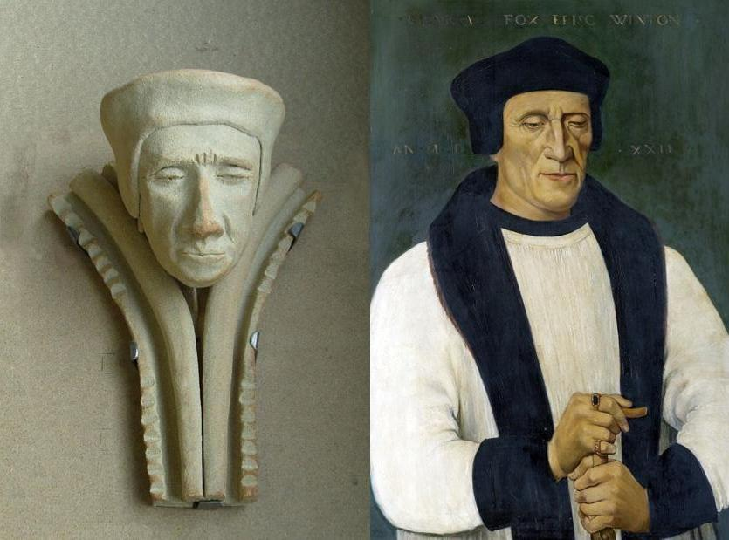
Richard Fox (1501-1528). For most of his time as Bishop of Winchester he was blind. He liked to visit the hostelries in Castle Street, and built the steps leading down to the town with seven steps followed by seven paces followed by 7 steps etc which are still there today. More pertinently this would have facilitated his trip back to the castle, following a visit to the hostelries. He is portrayed in the sculpture with his eyes half closed, and suffering from the vagaries of old age, the seven steps shown extending up the arch on either side.

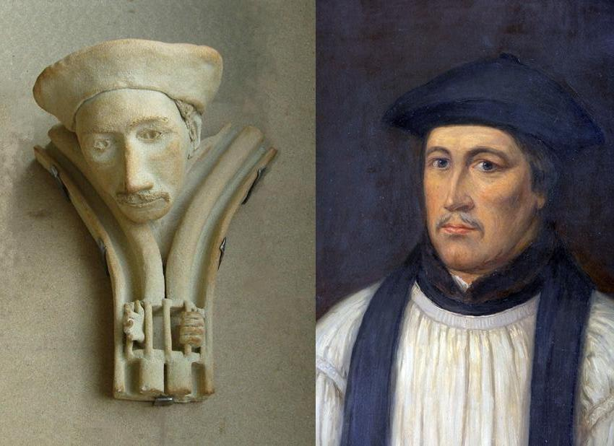
Stephen Gardiner (1531-1551) (1553-1555) He was imprisoned from 1551-1553 in the Tower. He is portrayed as a rather shifty character who would change his opinion according to who was listening..

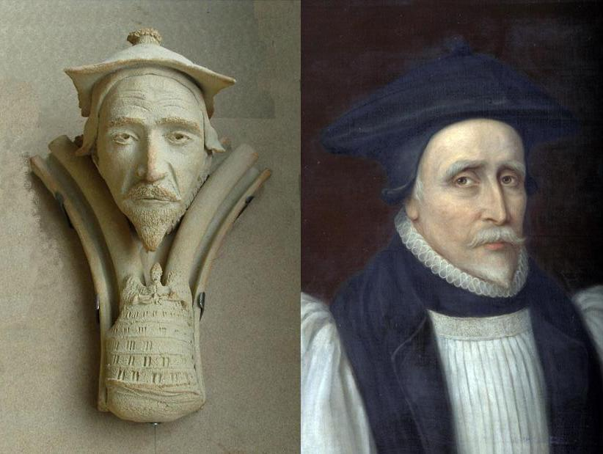
Lancelot Andrews (1618-1626) Known as the saintly bishop, or the “Angel in the pulpit”, as he was so good at preaching. He was the first person to wear the Bishop Andrews cap, which is still recognised today. He was very pious, and can be seen here looking up to heaven. He spoke 15 modern languages, and is here preaching from the “Tower of Babel” pulpit. The latter was taken from the representation of the Tower of Babel by Brueghel

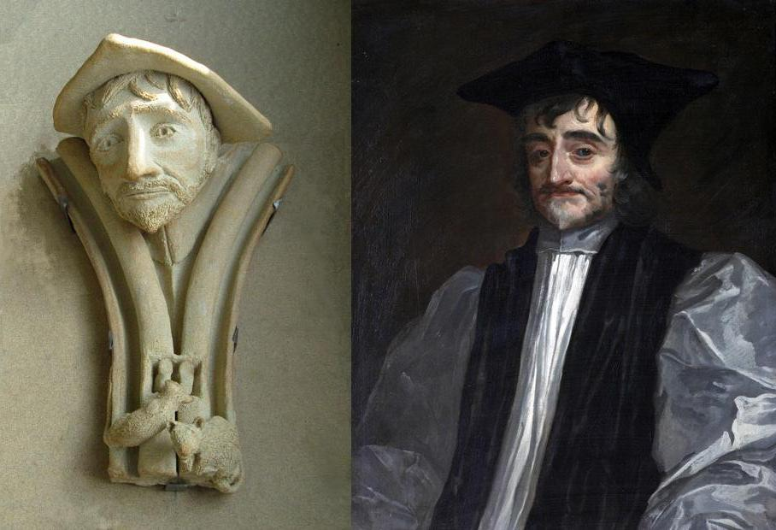
George Morley (1662-1684) Renowned as a brilliant, kind and generous man. His tenancy as the Bishop of Winchester however was during the time when the Black Death raged in England, which decimated the local population. (Carried by fleas that live on the rats) He was something of an ascetic person who led a very frugal life, rising at 5 am, only ate once/day, never had any heating in his room, and lived in a small cell under the stairs.

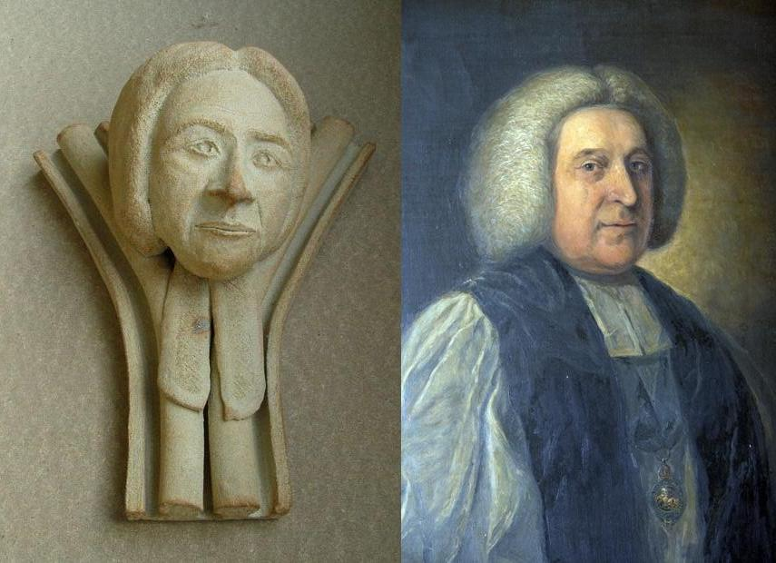
John Thomas (1761-1781) Tutor to George III, the King, Queen and some of the numerous children often visited him at the castle. The wig he wears is typical of the time.

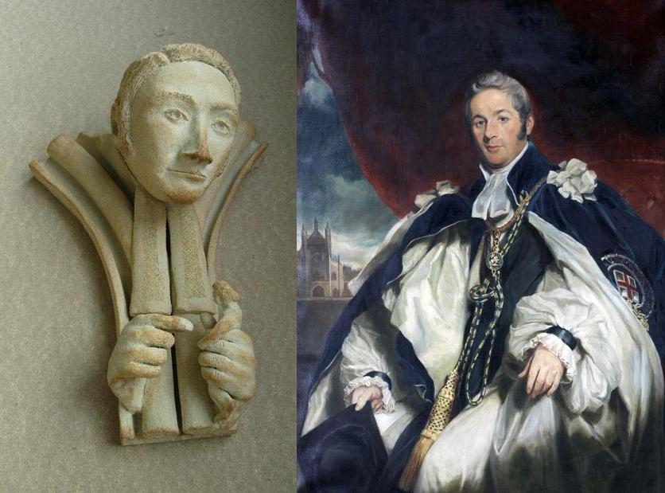
Charles Richard Sumner (1827-1869) He was a “Gentleman” Bishop who wrote a racy novel as a student, and married “Jenny” who was reportedly pregnant by one of the Royal family. He voted against the Great Reform Bill of 1832, which was also known as the Emancipation Bill. Emancipation comes from the Latin “Ex manus capire” or free from the hand. He is shown here holding a person, with the other hand poised above it as though he is questioning whether to release them. He was the last of the “Prince” bishops.

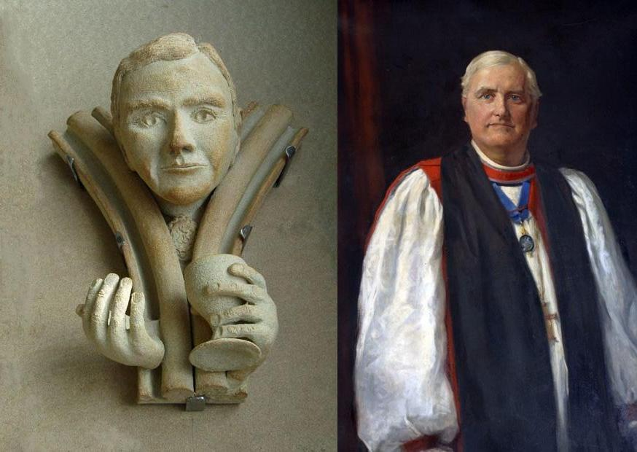
Frank Theodore Woods (1923-1932) He was the last bishop; and renowned for generous entertaining at the Castle. He is portrayed with a kind and generous face and a welcoming gesture.

For information about opening times See Farnham castle
Return to www.summerhays.co.uk

